**Analyzing International Debt Statistics using Python**

*A project by*

Siddhant Chamoli

[chxmoli@gmail.com](mailto:chxmoli@gmail.com)

**Introduction:**

Analyzing countries' international debt is an important topic of economic study since it gives information on a country's financial health and sustainability. This research is critical for comprehending the dynamics of global finance, especially in developing and emerging nations that rely largely on external borrowing. The World Bank and the International Monetary Fund (IMF) are important institutions that collect and analyze debt statistics, giving useful information to policymakers, academics, and financial experts.

**Importance of International Debt Analysis:**

International debt analysis examines the quantity and structure of debt that governments owe to international creditors. This comprises both public debt, which is usually issued by governments, and private debt, which is incurred by private sector firms. The relevance of this research stems from its capacity to analyze a country's creditworthiness, evaluate the dangers connected with debt levels, and develop plans for long-term economic growth. High debt levels may lead to financial crises, as evidenced by several historical situations in which governments defaulted on their debts, resulting in severe economic consequences.

**Data Collection & Methodology:**

The World Bank's International Debt Report (IDR) and International Debt Statistics (IDS) offer comprehensive databases for tracking external debt across nations. These publications collect data from low- and middle-income countries that use the World Bank's Debtor Reporting System (DRS). The data set contains total external indebtedness, debt service payments, and debt composition by creditor type, which may be used to determine trends and patterns in foreign borrowing.

To successfully analyze this data, researchers frequently use statistical methods and technologies like SQL for data processing and visualization. By querying the databases, researchers may extract key metrics such as overall debt, long-term vs short-term debt, and the influence of external shocks on debt sustainability. This mathematical method provides a more sophisticated understanding of how debt levels influence economic performance and stability.

**Key Indicators in Debt Analysis:**

Few Key Indicators are vital in the analysis of International Debt, they are:

1. **Debt-to-GDP Ratio:** This ratio represents a country's overall debt in relation to its GDP. A high debt-to-GDP ratio may suggest that a country is over-leveraged, posing challenges in paying debt commitments.
2. **Debt Service Ratio:** This ratio measures the proportion of a country's export profits utilised to pay debt. A larger percentage implies a bigger load on the economy and may indicate possible liquidity concerns.
3. **Composition of Debt:** Understanding the different forms of debt (public vs. private, bilateral vs. multilateral) is critical when analyzing risk. Different forms of debt have different terms and circumstances, which can impact a country's financial stability.
4. **Creditor Composition:** Analyzing the creditors (e.g., international financial institutions, foreign governments, private lenders) helps to understand the geopolitical consequences of debt and its capacity to affect domestic policy.

**Challenges in Debt Analysis:**

Despite the availability of data, analyzing international debt poses various obstacles. Data quality and consistency might differ greatly between nations, making cross-country comparisons challenging. Furthermore, the complexity of debt instruments and the changing structure of global finance necessitate ongoing revisions to analytical frameworks and procedures.

Finally, analyzing nations' foreign debt is a multidimensional endeavor that combines statistical rigor and economic theory. Researchers may give useful insights that guide policy choices and help global economic stability by using extensive information from institutions such as the World Bank and the IMF. Understanding these processes is critical, especially in a world where financial interconnectedness is increasing, and debt has global consequences.

**Code(s) & Explanations:**

* Loading the dataset & Importing Libraries needed

* Understanding the Dataset Format & Structure

* Exploring Key Metrics

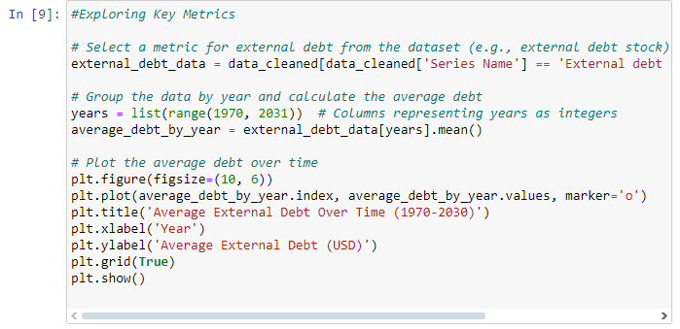

* Country Level Analysis

* Finding Correlation Between Debt Metrics

**Analyzing Parameter(s)**

**External Debt Stocks (Total)**

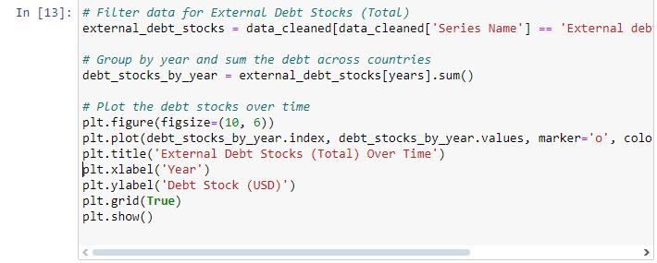

**Debt Service on External Debt (Total)**

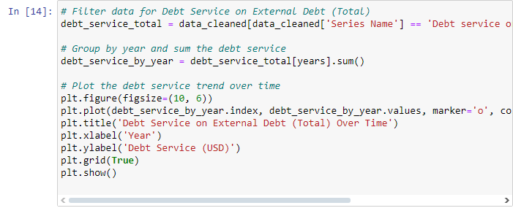

**Net Flows on External Debt**

**Interest Payments on External Debt**

**Average Grace Period on External Debt**

**Per Capita Debt Over Time**

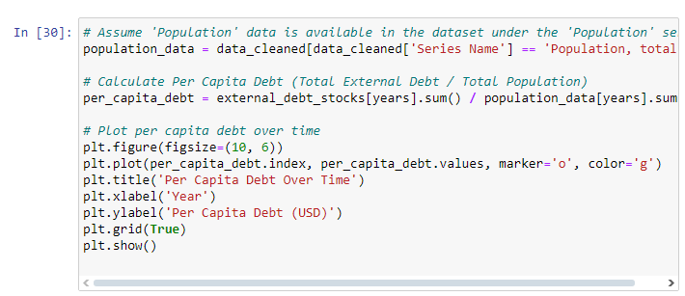

**Total Debt Service to Exports Ratio Over time**

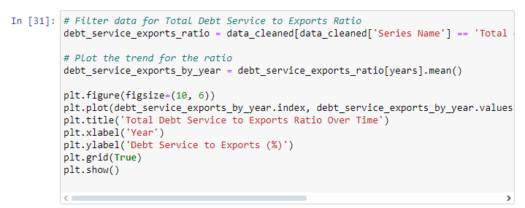

**External Debt Stock to GNI Ratio Over Time**

**Takeaways from this Project**

Through the **International Debt Analysis Project**, I have gained a deeper understanding of global economic patterns, particularly in relation to how countries manage external debt. By examining key metrics such as **external debt stocks** and **debt servicing**, I’ve developed a clearer picture of the interplay between debt and economic growth. A key takeaway from the project was the analysis of **external debt trends** over the years 1970 to 2030. Countries like the United States and China consistently showed high levels of external debt, while developing nations, such as India and Brazil, saw sharp increases, especially in 2020. This reflects how the global economy was impacted by the COVID-19 pandemic.

Made By: Siddhant Chamoli

Email: [chxmoli@gmail.com](mailto:chxmoli@gmail.com)

LinkedIn: <https://www.linkedin.com/in/siddhantchamoli/>